How to Scan/Email a Document

Step 1: Put the paper(s) into the top feed.
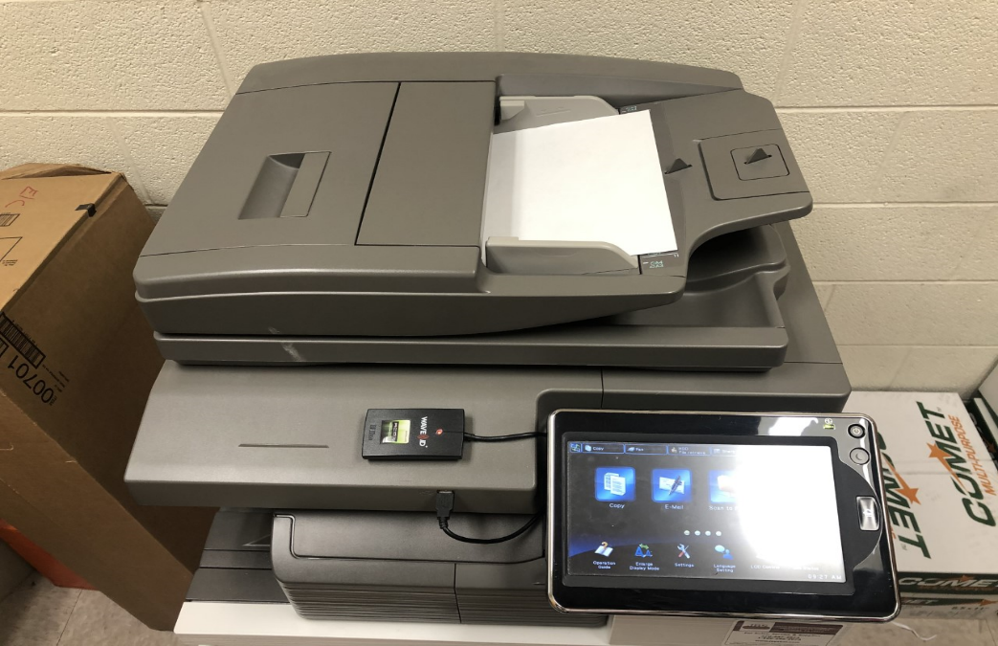

Step 2: Touch the E-mail icon.
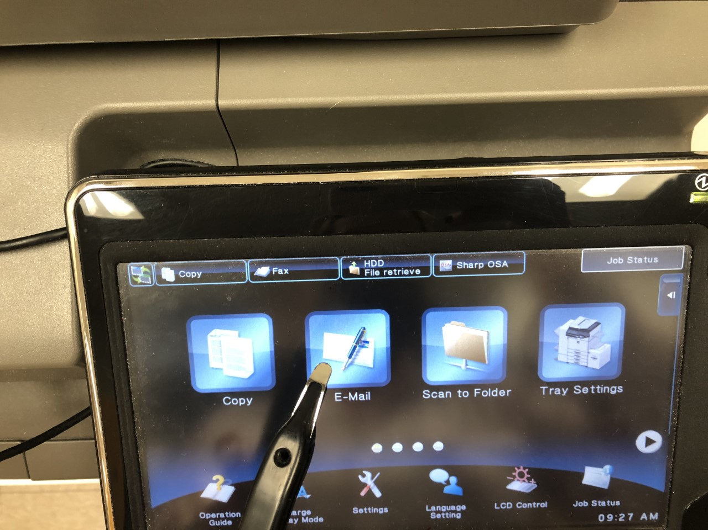
Step 3: Touch the address book, find your name and select it.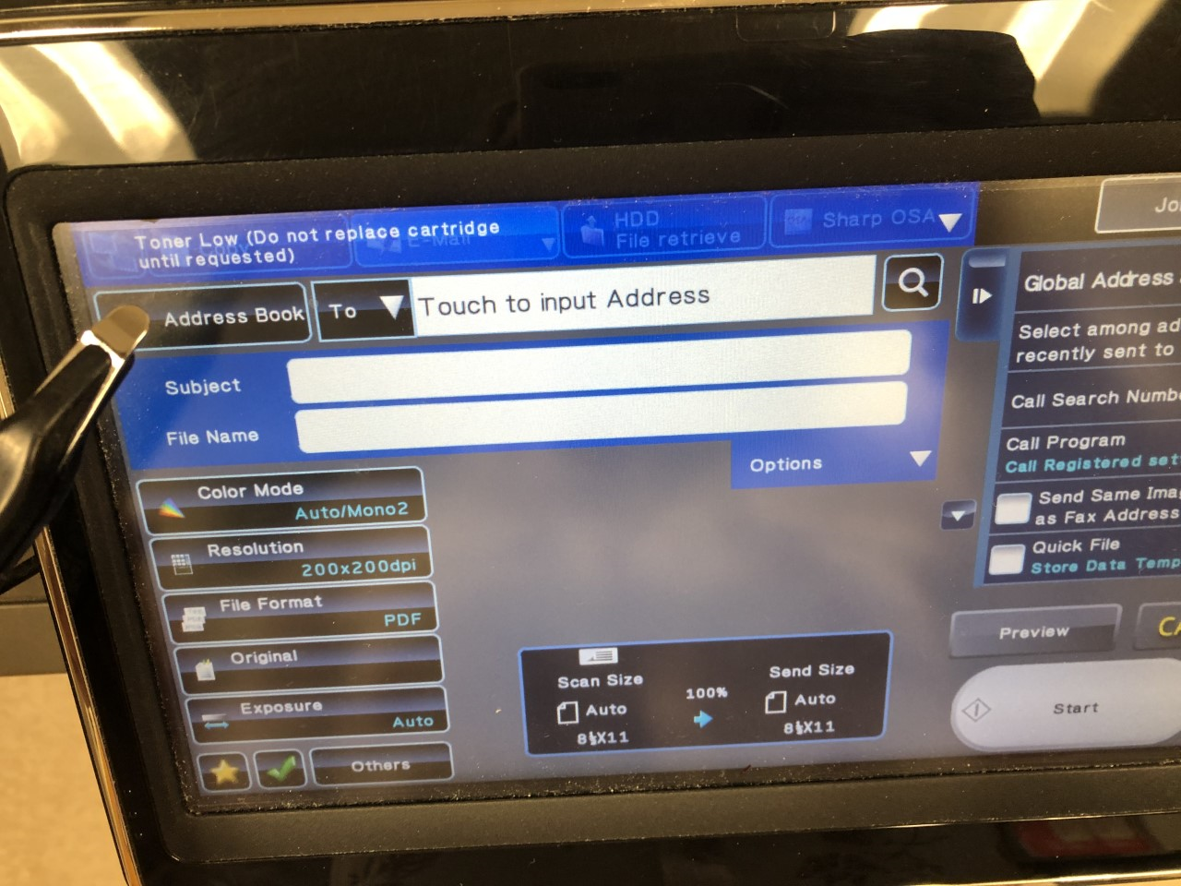

If it is not in the address book, enter address by keyboard.
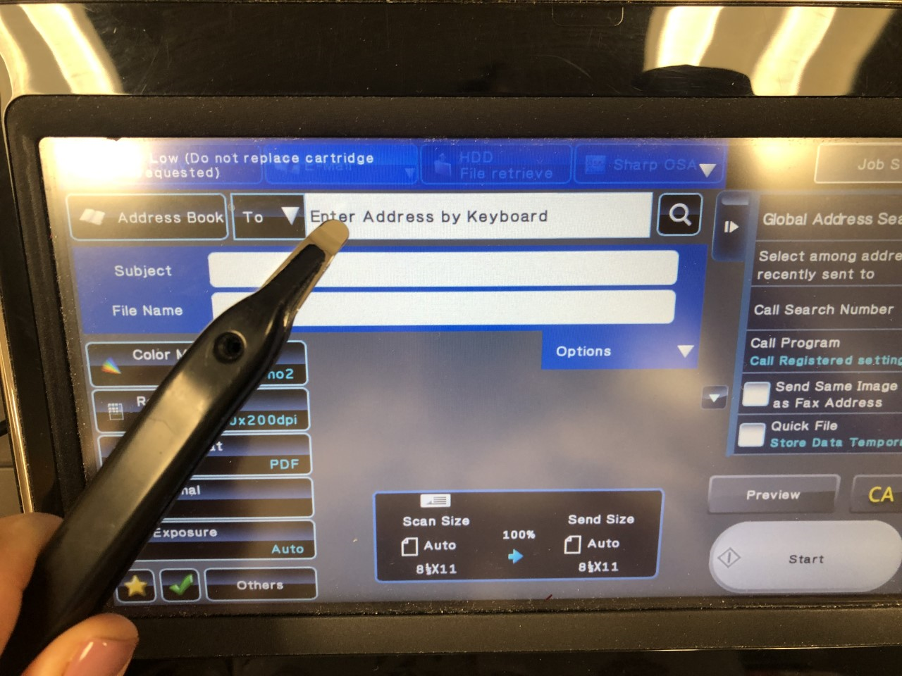

Step 4: Select the Original icon on the left of the screen. 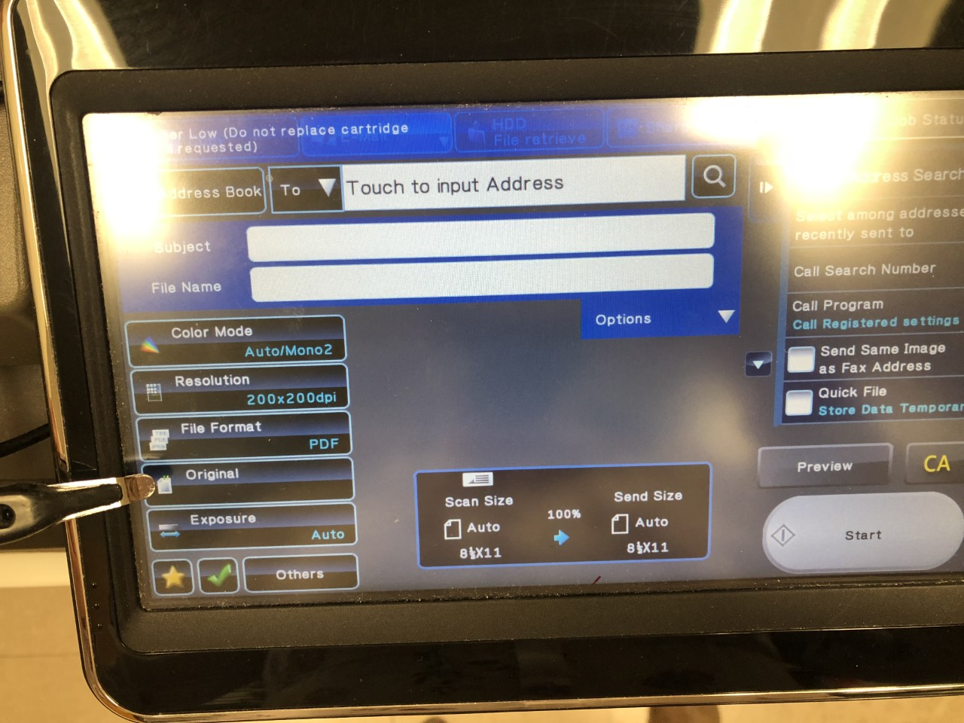

Step 5: Pick if the paper(s) are on one side or double sided and press ok in the top right.
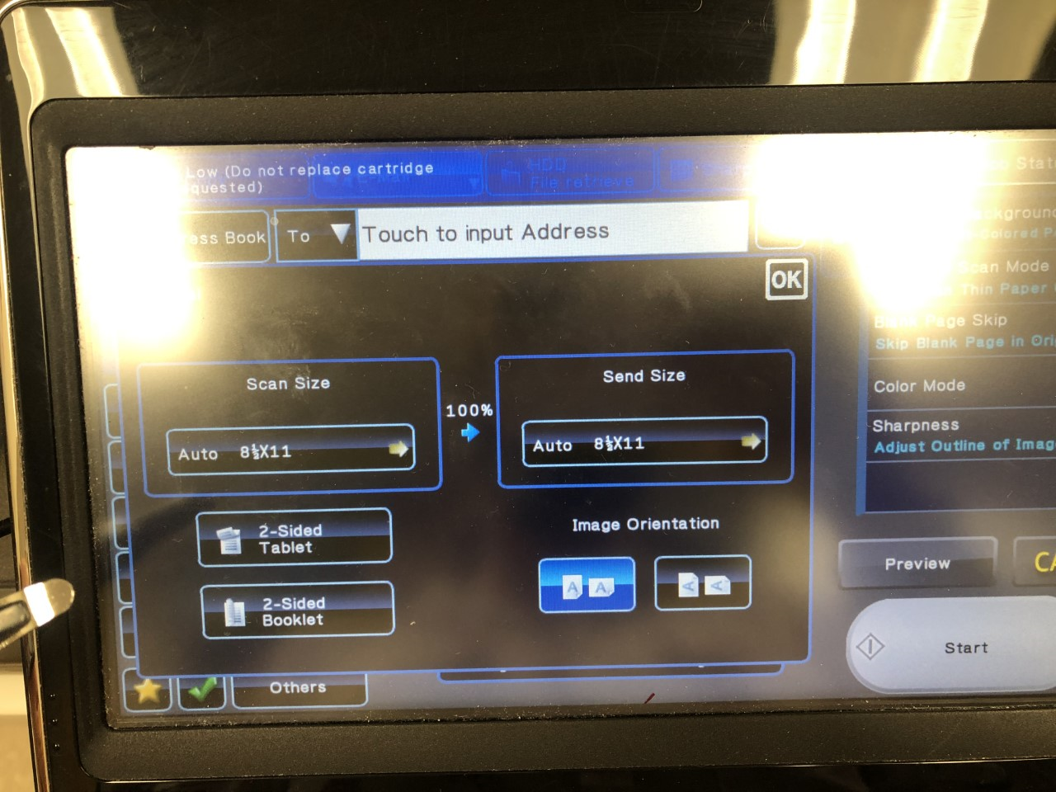

Step 6: Press the Start button on the right.

